
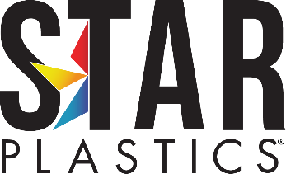

Regulatory Statement

03-01-2019
To Whom It May Concern:

This is to certify that Star Plastics Inc. materials do not contain any of the following concerns:

Asbestos Conflict Minerals Mica

Best Regards,

Star Plastics, Inc.
Technical Lead

Bob Powers

03-01-2019

bpowers@starplastics.com 304-273-0352

1 Plastics Avenue, P.O. Box 249, Ravenswood, WV 26164
326 Jack Burlingame Drive, Millwood, WV 25262 www.StarPlastics.com

