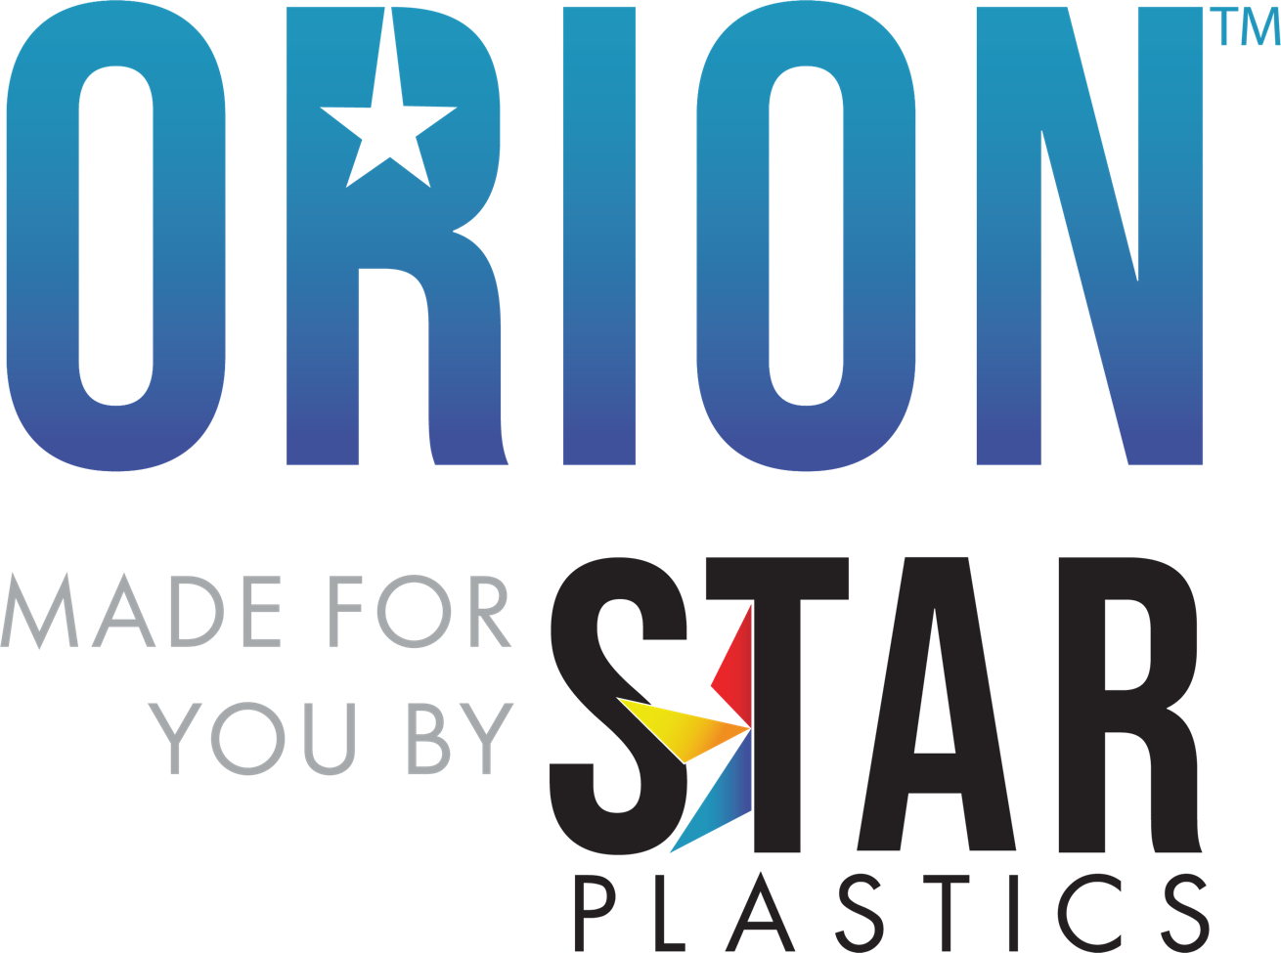

Grade: Orion™ PCHC7300 (f1)
Molding Grade PCFR w/ UV and Release, All Colors but Clear
NCNB (Non-Chlorinated & Non-Brominated) FR PC
Typical Material Properties

Physical | Nominal Values | ASTM Test
Specific Gravity | 1.10 | D792
Melt Flow (300°C/1.2 kg) | 12.0 g/10 min | D1238
Mechanical
Tensile Modulus | 310,000 psi | D638
Tensile Strength @ Yield | 7,200 psi | D638
Flexural Modulus | 310,000 psi | D790
Flexural Strength @ Yield | 10,000 psi | D790
Impact
Notched Izod Impact (73°F, 0.125 in) | 14.0 ft-lb/in | D256
Thermal
DTUL @ 264 psi – Unannealed (0.125 in) | 260°F | D648
Mold Shrinkage
Linear Flow | .005 – .008 in/in | D955
UL Rating | (f1) | UL746C
Flammability | V-0 @ 1.5mm | UL 94
RTI  Non-Chlorinated & Non-Brominated | 125°C, 115°C, 125°C | UL746B  UL746H
The information provided above is based upon typical values, and is intended only as a guide. Star Plastics, LLC assumes no obligation or liability for any advice furnished or for any results obtained with respect to this information. No guarantees or warranties are expressed or implied.

Orion™ is a registered trademark of Star Plastics, LLC, its subsidiaries or affiliates.
Recommended Processing Guidelines

Nominal Values
Drying Time and Temperature | 4.0 hrs at 250°F
Suggested Max Moisture | 0.020%
Rear Temperature | 520 – 550°F
Middle Temperature | 530 – 570°F
Front Temperature | 550 – 600°F
Nozzle Temperature | 550 – 600°F
Processing (Melt) Temperature | 550 – 600°F
Mold Temperature | 170 – 220°F
Back Pressure | 50 – 100 psi
Screw Speed | 40 – 75 RPM
The conditions listed above are only guidelines. You may want to adjust conditions to meet your requirements.

Rev0 Technical Data Sheet Access: 5/9/23

