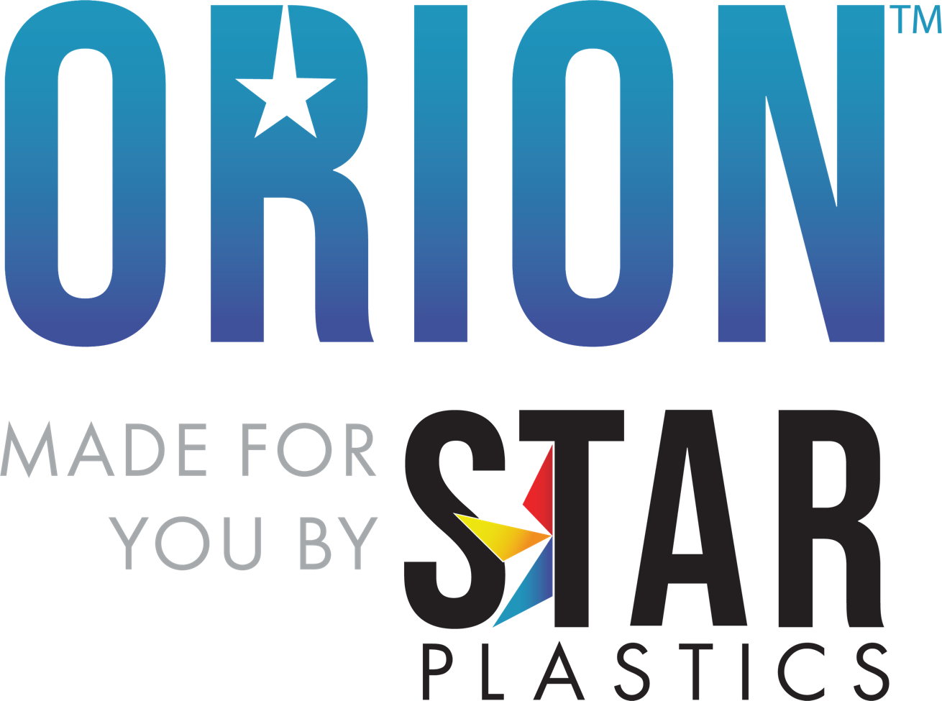

Grade: Orion™ PCHC7550 (f1)
Molding Grade PCFR w/ UV, R, Cold Temp Impact Modified; In Black, Gray & Beige,
Non-Chlorinated & Non-Brominated
Typical Material Properties
Physical | Nominal Values | ASTM Test
Specific Gravity | 1.19 | D792
Melt Flow (300°C/1.2 kg) | 10.0 g/10 min | D1238
Mechanical
Tensile Modulus | 320,000 psi | D638
Tensile Strength @ Yield | 8,400 psi | D638
Flexural Modulus | 348,000 psi | D790
Flexural Strength @ Yield | 9,000 psi | D790
Impact
Notched Izod Impact (73°F, 0.125 in)  Notched Izod Impact (-40°F, 0.125 in) | 17.0 ft-lb/in  14.0 ft-lb/in | D256  D256
Thermal
DTUL @ 264 psi – Unannealed (0.125 in) | 275°F | D648
Mold Shrinkage
Linear Flow | .004 – .008 in/in | D955
UL Rating | (f2) | UL746C
Flammability | V-0 @ 1.5mm, 5VA @ 2.5mm | UL 94
RTI  Non-Chlorinated & Non-Brominated | 125°C, 115°C, 125°C | UL746B  UL746H
Electrical
Dielectric Constant 60Hz  Dielectric Constant 1MHz | 2.95  2.90 | ASTM D150  ASTM D150
The information provided above is based upon typical values, and is intended only as a guide. Star Plastics, LLC assumes no obligation or liability for any advice furnished or for any results obtained with respect to this information. No guarantees or warranties are expressed or implied. *Orion™ is a registered trademark of Star Plastics, LLC, its subsidiaries or affiliates.
Recommended Processing Guidelines

Nominal Values
Drying Time and Temperature | 4.0 hrs at 250°F
Suggested Max Moisture | 0.020%
Rear Temperature | 520 – 550°F
Middle Temperature | 530 – 570°F
Front Temperature | 550 – 600°F
Nozzle Temperature | 550 – 600°F
Processing (Melt) Temperature | 550 – 600°F
Mold Temperature | 170 – 220°F
Back Pressure | 50 – 100 psi
Screw Speed | 40 – 75 RPM
The conditions listed above are only guidelines. You may want to adjust conditions to meet your requirements.
Rev0 Technical Data Sheet Access: 5/9/23

