
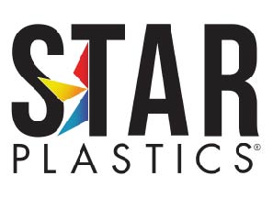

PFAS Regulatory Statement

Star Plastics
326 Jack Burlingame Drive Millwood, WV 25262

To Whom It May Concern:
In compliance with the requirements under the Toxics Substances Control Act (TSCA).

Re-PCR-FR2117(f1)
Is in compliance with, does not contain, or have added any PFAS. To learn more about PFAS, visit www.EPA.gov.
Best Regards,

Bob Powers
Bob Powers |Technical Manager
bpowers@starplastics.com
Star Plastics 304-273-0352

The information and recommendations set forth herein (hereinafter "the information") are presented in good faith and believed to be correct as of the date hereof. However, we make no representation as to the completeness or accuracy thereof. The information is supplied upon the condition that persons receiving it will make their own independent determination to confirm its suitability for their purpose prior to any use. All tests for the compatibility of the items manufactured for customer’s intended use are the sole responsibility of customer. In no event will we be responsible for damages of any nature whatsoever resulting from the use of or reliance upon the information. No representations or warranties either expressed or implied, or merchantability, fitness for a particular purpose or of any other nature are made hereunder with respect to the information, and for any materials to which information refers.

1 Plastics Avenue, P.O. Box 249, Ravenswood, WV 26164
326 Jack Burlingame Drive, Millwood, WV 25262 www.StarPlastics.com

