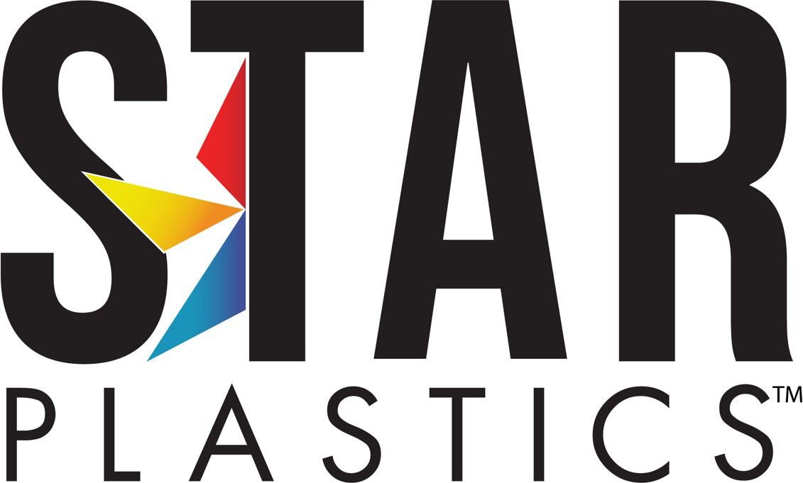

## reNova™ - re-PCR-FR1004(f1)

Access Date: 4/17/2023

**MSDS No. POLYCARBONATE FR**

Page 1



Safety Data Sheet

# Section 1: Identification

**Product Identifier:** Poly(Bisphenol-A)carbonate

**Chemical Formula:** Poly (bisphenol-A carbonate)with tetra bromobisphenol-A carbonate oligomer

**General Product Use:** May be used to produce molded or extruded articles or as

a component of other industrial products.

**Manufacturer:** Star Plastics, Inc.

326 Jack Burlingame Drive Millwood, West Virginia 25262, USA StarPlastics.com

Phone: 304.273.0352 (24 Hours)

Fax: 304.273.0355

**Emergency Telephone Number:** 304.273.5326 (24 hours)

# Section 2: Hazard(s) Identification

**Classifications:** Use Appendices to 1910.1200 to determine Hazard Classification.

**Pictograms:**

**Signal Word:** Warning

**Hazard Statements:** Spilled pellets create slipping hazard.

**Precautionary Statements:** Fumes produced during melt processing may cause

eye, skin, and respiratory tract irritation.

**Other Hazards Not Otherwise Classified:** Pellet inhalation unlikely due to physical form.

# Section 3: Composition/Information on Ingredients

|  |  |  |
| --- | --- | --- |
| **Chemical/Component Name** | **CAS Number** | **Weight %** |
| Polycarbonate | 111211-39-3 |  |
| *for codes containing UV stabilizers ….* |  |  |
| 2-(2Hydroxy-5-tert-octylphenyl) benzotriazole | 95-14-7 |  |
| *for codes containing high black content ….* |  |  |
| Carbon Black  *for codes containing high white content ….* | 1333-86-4 |  |
| Titanium Dioxide | 13463-67-7 |  |

**Section 4: First-Aid Measures**

**Inhalation:** Fume inhalation: Leave contaminated area and breathe fresh air. If coughing, difficult breathing or any other symptoms develop, seek medical attention at once, even if symptoms develop at a later time.

**Eye Contact:** Flush immediately with large amounts of water for at least 15 minutes. If irritation persists, call medical support.

**Skin Contact:** For skin contact with fume condensate, immediately wash thoroughly with soap and water. If irritation develops, seek medical attention.

For molten plastic skin contact, cool rapidly with water and immediately seek medical attention. Do not attempt removal of plastic without medical assistance. Do not use solvent for removal.

**Ingestion:** Not probable.

**Most Important Symptoms/Effects:**

**Indication of Immediate Medical**

**Treatment:**

Fumes produced during melt process of plastics may produce acute health effects in some individuals, especially irritation of eyes/nose and throat in cases of severe overexposure, nausea and headaches.

Molten plastic can cause severe thermal burns. Fumes produced during melt processing may cause eye, skin and respiratory tract irritation.

# Section 5: Fire-Fighting Measures

**Suitable (and Unsuitable) Extinguishing Media:**

**Specific Hazards Arising from the Chemical:**

**Special Protective Equipment and Precautions for Fire-**

**fighters:**

Water spray and foam. Water is the best extinguishing medium. Carbon dioxide and dry chemical are not generally recommended because their lack of cooling capacity may permit re-ignition.

Hazardous combustion products may include intense heat, dense black smoke, carbon monoxide, carbon dioxide and hydrocarbon fragments.

Wear NIOSH/MSHA approved SCBA and full protective equipment.

The fuel content and temperatures will require immediate attention and vigorous efforts to bring about control of the fire, and suppression of the fire should begin immediately. The plastic will melt, but it will not be carried on the surface of the water, and water can be freely used to control the fire. Use a water spray to cool fire-exposed containers, and to solidify. Do not release runoff from fire control methods to sewers or waterways.

# Section 6: Accidental Release Measures

**Personal Precautions/Protective Equipment/Emergency**

**Procedures: Methods/Materials for Containment & Clean-Up:**

Pellets: Remove from all floor areas to allow for stable footing and preventing slips by personnel.

Soil: Collect for re-use or appropriate disposal. Solids can be separated.

Water: Notification of government agency may be appropriate. Air: Not likely to be released.

# Section 7: Handling and Storage

**Precautions for Safe Handling:**

**Conditions for Safe Storage:**

Secondary operations such as grinding, sanding or sawing may produce a dust explosion hazard. Use aggressive housekeeping activities to prevent dust accumulation; employ bonding, grounding, venting and explosion relief provisions in accordance with accepted engineering practices.

Avoid storing containers near foodstuffs due to possibility of odor and taste contamination of food.

Do not store containers near heating devices, hot pipes, etc.

Store in a dry place away from moisture, excessive heat and sources of ignition. Read and become familiar with all labels and instructions of packaging.

# Section 8: Exposure Controls/Personal Protection

OSHA PEL/ACGIH/TLV:

*for codes containing high black content ….*

OSHA PEL (TWA) STEL Ceiling

Carbon Black 3.5 mg/m3

*for codes containing high white content ….*

Titanium Dioxide 15 mg/m3

**Appropriate Engineering Controls: Individual Protection**

**Measures:**

**Respiratory Protection:**

Recommended, sufficient ventilation to control fumes.

Under conditions of excessive fume concentration, a NIOSH/MSHA approved device with organic vapor acid gas rating or fresh air supply should be used. Seek professional advice prior to respirator selection and use. Follow OSHA respirator regulations (29 CFR 1910.134) and, if necessary, wear a MSHA/NIOSH-approved respirator. Select respirator based on its suitability to provide adequate worker protection for given working conditions, level of airborne contamination, and presence of sufficient oxygen. For emergency or nonroutine operations (cleaning spills, reactor vessels, or storage tanks), wear an SCBA. *Warning! Air-purifying respirators do not protect workers in oxygen- deficient atmospheres.* If respirators are used, OSHA requires a written respiratory protection program that includes at least: medical certification, training, fit-testing, periodic environmental monitoring, maintenance, inspection, cleaning, and convenient, sanitary storage areas.

**Hand Protection:** Wear gloves that will prohibit penetration when handling hot plastic.

**Eye Protection:** ANSI approved safety glasses or chemical workers goggles.

**Other Protective Equipment: Work Hygienic**

**Practices:**

Ordinary work clothes.

Wash hands with soap and water before eating or smoking and at the end of each work day.

# Section 9: Physical and Chemical Properties

**Appearance (Physical** Solid, plastic pellet **Explosive Limits:** Unknown

**State, Color, etc.):**

**Odor:** Slight **Vapor Pressure:** Negligible

**Odor Threshold:** N/A **Vapor Density:** Unknown

**pH:** N/A **Relative Density:** Unknown

**Freezing/Melting Point:** This product does not

exhibit a sharp melting point, but softens gradually over a wide temperature range.

**Solubility:** Insoluble

**Boiling Point/Range:** N/A **Other Solubility:** Unknown

**Flash Point:** Unknown **Partition Coefficient:** Unknown

**Evaporation Rate:** N/A **Auto-Ignition Temp:** 630°C (1,166°F),

estimated

**Flammability (Solid,** N/A **Decomposition Temp:** Unknown

**Gas):**

**Viscosity:** N/A **UEL/LEL:** Unknown

# Section 10: Stability and Reactivity

**Reactivity:** Not reactive under recommended conditions of handling, storage, processing and use.

**Chemical Stability:** Stable under recommended conditions of storage and handling.

**Possibility of Hazardous Reactions:**

**Conditions to Avoid:** Do not exceed melt temperature recommendations in product literature. In order to avoid autoignition/hazardous decomposition of hot thick masses of plastic, purgings should be collected in small, flat shapes or thin strands to allow for rapid cooling and quench in water.

**Incompatible Materials: Hazardous Decomposition of**

**Products:**

Processing fumes evolved at recommended processing conditions may include trace levels of phenol, alkylphenols, and diarylcarbonates and hydrogen bromide.

# Section 11: Toxicological Information

Information on toxicological effects

**Routes of Exposure:** Inhalation, skin, ingestion

**Eye:** Product may cause irritation or injury due to mechanical action.

**Skin Contact:** Pellets not likely to cause skin irritation.

Molten plastic can cause severe thermal burns.

**Ingestion:** Not acutely toxic.

**Inhalation:** Pellet inhalation unlikely due to physical form.

**Symptoms:** Fumes produced during melt processing may cause eye, skin and respiratory tract irritation.

**Delayed & Immediate**

**Effects:**

**Numerical Measures of**

**Toxicity:**

Acute Effects: Fumes produced during melt process of plastics may produce acute health effects in some individuals, especially irritation of eyes/nose and throat in cases of severe overexposure, nausea and headaches. Fumes emitted from hot plastic during conversion may condense on cool overhead metal surfaces/structures.

Chronic Effects: None known.

**Carcinogenicity:** OSHA, IARC and NTP have listed carbon black as a carcinogen. Titanium Dioxide has been identified as a suspected or confirmed human carcinogen. OSHA, IARC and/or NTP have listed heavy metals, present in some colorants as carcinogens. These colorants are essentially bound to the plastic matrix and are unlikely to contribute to workplace exposure under recommended processing conditions.

# Section 12: Ecological Information (non-mandatory)

**Ecotoxicity:** N/A **Persistence and Degradability:** N/A **Bioaccumulation Potential:** N/A

**Mobility in Soil:** N/A

**Other Adverse Effects:** N/A

# Section 13: Disposal Considerations (non-mandatory)

Description of waste residues and information on their safe handling and methods of disposal, including the disposal of any contaminated packaging.

Landfill waste plastic if codes permit; incinerate if codes and equipment permit. Incinerating equipment should be capable of handling large volumes of dense, black smoke and withstand effects of acid gases. Pellet materials not considered hazardous waste.

# Section 14: Transport Information (non-mandatory)

**UN Number** N/A **UN Proper Shipping Name** N/A **Transport Hazard Class(es)** N/A **Packing Group, if Applicable** N/A

**Environmental Hazards (e.g., Marine Pollutant)** N/A

**Transport in Bulk (according to Annex II of MARPOL 73/78 and**

**the IBC Code) Special precautions that a user needs to be aware of, or needs to comply with, in connection with transport of conveyance**

**either within or outside their premises:**

N/A N/A

**DOT Transportation Data:** 49 CFR 172.101

# Section 15: Regulatory Information (non-mandatory)

Safety, Health and Environmental Regulations specific for the product in question.

**EPA Regulations:**

RCRA Hazardous Waste Number: Not listed (40 CFR 261.33)

RCRA Hazardous Waste Classification (40 CFR 261.??): Not classified

CERCLA Hazardous Substance (40 CFR 302.4) Unlisted specific per RCRA, Sec. 3001; CWA, Sec. 311 (b)(4); CWA, Sec. 307(a), CAA, Sec. 112

SARA Toxic Chemical (40 CFR 372.65): Not listed

SARA EHS (Extremely Hazardous Substance) (40 CFR 355): Not listed, Threshold Planning Quantity (TPQ)

**OSHA Regulations:**

Air Contaminant (29 CFR 1910.1000, Table Z-1, Z-1-A): Not listed OSHA Specifically Regulated Substance: Not listed

**State Regulations:**

**California Proposition 65:**

**WARNING:** This product can expose you to chemicals: Dichloromethane (CAS# 75-09-2), Bisphenol A (CAS# 80-05-7), Tetrabromobisphenol A (CAS# 79-94-7) which is [are] known to the State of California to cause cancer, birth defects or other reproductive harm.

For more information, go to [www.P65Warnings.ca.gov.](http://www.P65Warnings.ca.gov/)

**Listed on the active section of the TSCA Inventory**

# Section 16: Other Information

***Prepared By:*** *Star Plastics, Inc* ***Date of Preparation:*** *4/17/23* ***Revision:*** *01*

*This information is offered in good faith as typical values and not as a product specification. No warranty, expressed or implied is hereby made. The recommended industrial hygiene and safe handling procedures are believed to be generally applicable. However, each user should review these recommendations in the specific context of the intended use and determine whether they are appropriate.*