AdvanSix cuts nylon production to manage inventory amid weak demand

Don Loepp
Editor
Plastics News Editor
Reprints
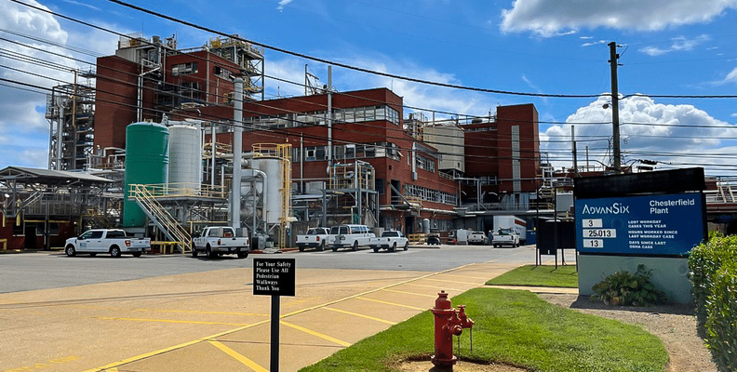
AdvanSix
An electrical outage and small fire at the AdvanSix nylon plant in Chesterfield, Va., in September, will affect its fourth-quarter earnings.
AdvanSix Inc. is pulling back nylon production to align with continued weak market demand, the company said in its third-quarter earnings report released Nov. 7.
The Parsippany, N.J.-based chemical maker saw its nylon sales fall 16 percent in the quarter compared to the prior year, dropping to $79 million, or 21 percent of total sales. President and CEO Erin Kane said AdvanSix is slowing production to avoid excess inventory and protect cash flow during a prolonged nylon downturn.
"We're making the strategic choice to moderate production rates to manage inventory levels, with a keen focus on free cash flow," Kane said during the company's earnings call. "We are seemingly operating in a lower-for-longer macro environment."
Kane said utilization across AdvanSix's integrated value chain was down roughly four percentage points from the second quarter to the third.
The company also had an electrical outage and small fire at its Chesterfield, Va., nylon plant in September, which Kane said will impact fourth-quarter earnings by $7 million to $9 million due to unabsorbed fixed costs. Operations have since resumed, with no injuries or environmental issues.
Third-quarter sales totaled $374 million, down 6 percent from the same period in 2024. AdvanSix reported an adjusted EBITDA of $24.7 million, down nearly half from last year.
Looking ahead, AdvanSix expects capital expenditures of $120 million to $125 million for the full year — a $30 million reduction from its earlier forecast, due to what Kane called "refined risk-based prioritization."
AdvanSix manufactures caprolactam, nylon 6 and other intermediates used in plastics, agriculture, coatings and solvents. It operates five U.S. production sites and sells mostly into the domestic market, where it benefits from tariffs on imported materials.
Kane said AdvanSix remains focused on "controllable levers," such as managing production and optimizing its product mix, to maintain profitability during market cycles.

